**Creating Tables:**

CREATE TABLE Customer (

CustomerID INT NOT NULL AUTO_INCREMENT,

Name VARCHAR(255) NOT NULL,

Email VARCHAR(255) NOT NULL UNIQUE,

PhoneNumber VARCHAR(255) NOT NULL,

Address VARCHAR(255) NOT NULL,

DateOfBirth DATE NOT NULL,

PRIMARY KEY (CustomerID)

);

CREATE TABLE CinemaHall (

CinemaHallID INT NOT NULL AUTO_INCREMENT,

Name VARCHAR(255) NOT NULL UNIQUE,

Location VARCHAR(255) NOT NULL,

NumberOfScreens INT NOT NULL,

PRIMARY KEY (CinemaHallID)

);

CREATE TABLE Showtime (

ShowTimeID INT NOT NULL AUTO_INCREMENT,

MovieID INT NOT NULL,

CinemaHallID INT NOT NULL,

Date DATE NOT NULL,

Time TIME NOT NULL,

Price DECIMAL(10,2) NOT NULL,

PRIMARY KEY (ShowTimeID),

FOREIGN KEY (MovieID) REFERENCES Movie(MovieID),

FOREIGN KEY (CinemaHallID) REFERENCES CinemaHall(CinemaHallID)

);

CREATE TABLE Ticket (

TicketID INT NOT NULL AUTO_INCREMENT,

ShowID INT NOT NULL,

CustomerID INT NOT NULL,

SeatNumber INT NOT NULL,

Price DECIMAL(10,2) NOT NULL,

PRIMARY KEY (TicketID),

FOREIGN KEY (ShowID) REFERENCES showtime(ShowTimeID),

FOREIGN KEY (CustomerID) REFERENCES Customer(CustomerID)

);

CREATE TABLE Screen (

ScreenID INT NOT NULL AUTO_INCREMENT,

CinemaHallID INT NOT NULL,

NumberOfSeats INT NOT NULL,

PRIMARY KEY (ScreenID),

FOREIGN KEY (CinemaHallID) REFERENCES CinemaHall(CinemaHallID)

);

CREATE TABLE Seat (

SeatID INT NOT NULL AUTO_INCREMENT,

ScreenID INT NOT NULL,

RowNumber INT NOT NULL,

ColumnNumber INT NOT NULL,

PRIMARY KEY (SeatID),

FOREIGN KEY (ScreenID) REFERENCES Screen(ScreenID)

);

CREATE TABLE Payment (

PaymentID INT NOT NULL AUTO_INCREMENT,

TicketID INT NOT NULL,

PaymentType VARCHAR(255) NOT NULL,

Amount DECIMAL(10,2) NOT NULL,

Date DATE NOT NULL,

PRIMARY KEY (PaymentID),

FOREIGN KEY (TicketID) REFERENCES Ticket(TicketID)

);

CREATE TABLE Booking (

BookingID INT NOT NULL AUTO_INCREMENT,

CustomerID INT NOT NULL,

ShowTimeID INT NOT NULL,

TicketID INT NOT NULL,

PaymentID INT NOT NULL,

Date DATE NOT NULL,

PRIMARY KEY (BookingID),

FOREIGN KEY (CustomerID) REFERENCES Customer(CustomerID) ON DELETE CASCADE,

FOREIGN KEY (ShowTimeID) REFERENCES ShowTime(ShowTimeID) ON DELETE CASCADE,

FOREIGN KEY (TicketID) REFERENCES Ticket(TicketID) ON DELETE CASCADE,

FOREIGN KEY (PaymentID) REFERENCES Payment(PaymentID) ON DELETE CASCADE

);

CREATE TABLE Notification (

NotificationID INT NOT NULL AUTO_INCREMENT,

CustomerID INT NOT NULL,

Message VARCHAR(255) NOT NULL,

Date DATE NOT NULL,

PRIMARY KEY (NotificationID),

FOREIGN KEY (CustomerID) REFERENCES Customer(CustomerID)

);

CREATE TABLE Movie (

MovieID INT NOT NULL AUTO_INCREMENT,

Title VARCHAR(255) NOT NULL UNIQUE,

Genre VARCHAR(255) NOT NULL,

Language VARCHAR(255) NOT NULL,

ReleaseDate DATE NOT NULL,

Duration INT NOT NULL,

PRIMARY KEY (MovieID)

);

**Inserting Data:**

INSERT INTO Customer (Name, Email, PhoneNumber, Address, DateOfBirth)

VALUES

('John Doe', 'john.doe@example.com', '+15555555555', '123 Main Street, Anytown, CA 91234', '1980-01-01'),

('Jane Doe', 'jane.doe@example.com', '+15555555556', '456 Elm Street, Anytown, CA 91234', '1982-02-02'),

('Peter Parker', 'peter.parker@example.com', '+15555555557', '789 Oak Street, Anytown, CA 91234', '1984-03-03'),

('Mary Jane Watson', 'maryjane.watson@example.com', '+15555555558', '1011 Maple Street, Anytown, CA 91234', '1986-04-04'),

('Harry Osborn', 'harry.osborn@example.com', '+15555555559', '1213 Pine Street, Anytown, CA 91234', '1988-05-05'),

('Gwen Stacy', 'gwen.stacy@example.com', '+15555555560', '1415 Elm Street, Anytown, CA 91234', '1990-06-06'),

('Flash Thompson', 'flash.thompson@example.com', '+15555555561', '1617 Oak Street, Anytown, CA 91234', '1992-07-07'),

('Betty Brant', 'betty.brant@example.com', '+15555555562', '1819 Maple Street, Anytown, CA 91234', '1994-08-08'),

('J. Jonah Jameson', 'j.jonah.jameson@example.com', '+15555555563', '2021 Pine Street, Anytown, CA 91234', '1996-09-09'),

('Robbie Robertson', 'robbie.robertson@example.com', '+15555555564', '2223 Elm Street, Anytown, CA 91234', '1998-10-10');

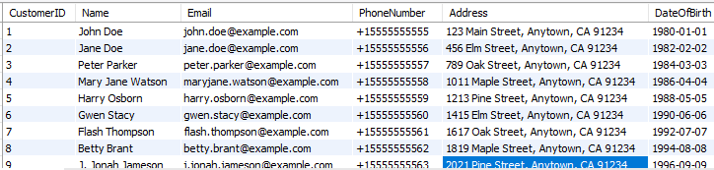

INSERT INTO CinemaHall (Name, Location, NumberOfScreens)

VALUES

('Cinema 1', '123 Main Street, Anytown, CA 91234', 5),

('Cinema 2', '456 Elm Street, Anytown, CA 91234', 7),

('Cinema 3', '789 Oak Street, Anytown, CA 91234', 3),

('Cinema 4', '1011 Maple Street, Anytown, CA 91234', 4),

('Cinema 5', '1213 Pine Street, Anytown, CA 91234', 6),

('Cinema 6', '1415 Elm Street, Anytown, CA 91234', 8),

('Cinema 7', '1617 Oak Street, Anytown, CA 91234', 2),

('Cinema 8', '1819 Maple Street, Anytown, CA 91234', 10),

('Cinema 9', '2021 Pine Street, Anytown, CA 91234', 9),

('Cinema 10', '2223 Elm Street, Anytown, CA 91234', 1);

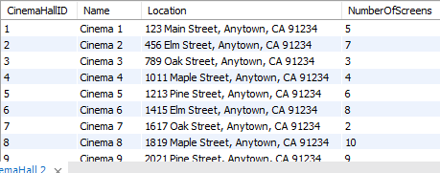

INSERT INTO Showtime (MovieID, CinemaHallID, Date, Time, Price)

VALUES

(31, 1, '2023-08-05', '19:00:00', 15.00),

(32, 2, '2023-08-05', '19:30:00', 16.00),

(33, 3, '2023-08-05', '20:00:00', 17.00),

(34, 4, '2023-08-05', '20:30:00', 18.00),

(35, 5, '2023-08-06', '19:00:00', 19.00),

(36, 6, '2023-08-06', '19:30:00', 20.00),

(37, 7, '2023-08-06', '20:00:00', 21.00),

(38, 8, '2023-08-06', '20:30:00', 22.00),

(39, 9, '2023-08-07', '19:00:00', 23.00),

(40, 10, '2023-08-07', '19:30:00', 24.00);

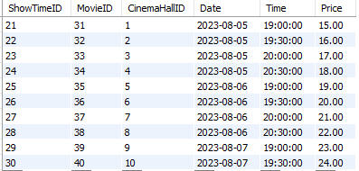

INSERT INTO Ticket (ShowID, CustomerID, SeatNumber, Price)

VALUES

(21, 1, 1, 15.00),

(22, 2, 2, 16.00),

(23, 3, 3, 17.00),

(24, 4, 4, 18.00),

(25, 5, 5, 19.00),

(26, 6, 6, 20.00),

(27, 7, 7, 21.00),

(28, 8, 8, 22.00),

(29, 9, 9, 23.00),

(30, 10, 10, 24.00);

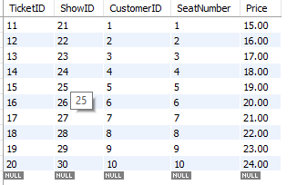

INSERT INTO Screen (CinemaHallID, NumberOfSeats)

VALUES

(1, 50),

(2, 70),

(3, 30),

(4, 40),

(5, 60),

(6, 80),

(7, 20),

(8, 100),

(9, 90),

(10, 10);

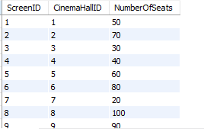

INSERT INTO Seat (ScreenID, RowNumber, ColumnNumber)

VALUES

(1, 1, 1),

(1, 1, 2),

(1, 2, 1),

(1, 2, 2),

(2, 1, 1),

(2, 1, 2),

(2, 2, 1),

(2, 2, 2),

(3, 1, 1),

(3, 1, 2),

(3, 2, 1),

(3, 2, 2);

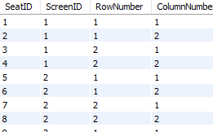

INSERT INTO Payment (TicketID, PaymentType, Amount, Date)

VALUES

(11, 'Credit Card', 15.00, '2023-08-05'),

(12, 'Debit Card', 16.00, '2023-08-05'),

(13, 'Net Banking', 17.00, '2023-08-05'),

(14, 'UPI', 18.00, '2023-08-05'),

(15, 'Wallet', 19.00, '2023-08-06'),

(16, 'Cash on Delivery', 20.00, '2023-08-06'),

(17, 'Credit Card', 21.00, '2023-08-06'),

(18, 'Debit Card', 22.00, '2023-08-06'),

(19, 'Net Banking', 23.00, '2023-08-07'),

(20, 'UPI', 24.00, '2023-08-07');

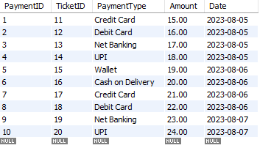

INSERT INTO Booking (CustomerID, ShowTimeID, TicketID, PaymentID, Date)

VALUES

(1,21, 11, 1, '2023-08-05'),

(2, 22, 12, 2, '2023-08-05'),

(3, 23, 13, 3, '2023-08-05'),

(4, 24, 14, 4, '2023-08-05'),

(5, 25, 15, 5, '2023-08-06'),

(6, 26, 16, 6, '2023-08-06'),

(7, 27, 17, 7, '2023-08-06'),

(8, 28, 18, 8, '2023-08-06'),

(9, 29, 19, 9, '2023-08-07'),

(10, 30, 20, 10, '2023-08-07');

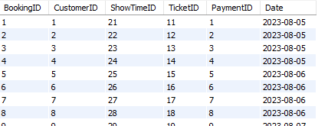

INSERT INTO Notification (CustomerID, Message, Date)

VALUES

(1, 'Your booking for ShowTimeID 1 has been confirmed.', '2023-08-05'),

(2, 'Your booking for ShowTimeID 2 has been confirmed.', '2023-08-05'),

(3, 'Your booking for ShowTimeID 3 has been confirmed.', '2023-08-05'),

(4, 'Your booking for ShowTimeID 4 has been confirmed.', '2023-08-05'),

(5, 'Your booking for ShowTimeID 5 has been confirmed.', '2023-08-06'),

(6, 'Your booking for ShowTimeID 6 has been confirmed.', '2023-08-06'),

(7, 'Your booking for ShowTimeID 7 has been confirmed.', '2023-08-06'),

(8, 'Your booking for ShowTimeID 8 has been confirmed.', '2023-08-06'),

(9, 'Your booking for ShowTimeID 9 has been confirmed.', '2023-08-07'),

(10, 'Your booking for ShowTimeID 10 has been confirmed.', '2023-08-07');

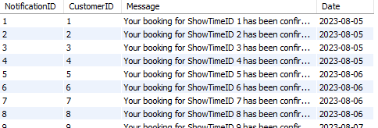

INSERT INTO Movie (Title, Genre, Language, ReleaseDate, Duration)

VALUES

('Top Gun: Maverick', 'Action', 'English', '2022-05-27', 126),

('Jurassic World Dominion', 'Adventure', 'English', '2022-06-10', 147),

('Minions: The Rise of Gru', 'Animation', 'English', '2022-07-01', 87),

('Thor: Love and Thunder', 'Action', 'English', '2022-07-08', 119),

('The Batman', 'Action', 'English', '2022-03-04', 176),

('Everything Everywhere All at Once', 'Action', 'English', '2022-03-25', 139),

('Turning Red', 'Animation', 'English', '2022-03-11', 105),

('The Lost City', 'Action', 'English', '2022-03-25', 112),

('Cyrano', 'Drama', 'English', '2022-02-25', 123),

('Death on the Nile', 'Mystery', 'English', '2022-02-11', 127);

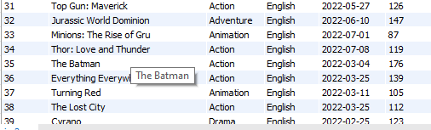

**Queries:**

Query 1:Get all showtime details, including the movie title, cinema hall name, date, and time.

SELECT Movie.Title, CinemaHall.Name, Showtime.Date, Showtime.Time

FROM Showtime

JOIN Movie ON Showtime.MovieID = Movie.MovieID

JOIN CinemaHall ON Showtime.CinemaHallID = CinemaHall.CinemaHallID;

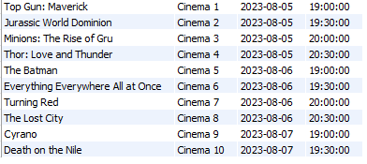

Query 2: Get all ticket details, including the showtime details, customer name, and seat number.

SELECT Showtime.MovieID, Showtime.CinemaHallID, Showtime.Date, Showtime.Time, Customer.Name, Ticket.SeatNumber

FROM Ticket

JOIN Showtime ON Ticket.ShowID = Showtime.ShowTimeID

JOIN Customer ON Ticket.CustomerID = Customer.CustomerID;

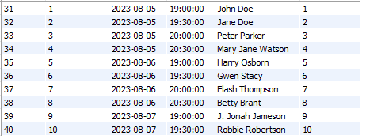

Query-3 : Get all payment details, including the ticket details, payment type, amount, and date.

SELECT Ticket.ShowID, Ticket.CustomerID, Ticket.SeatNumber, Payment.PaymentType, Payment.Amount, Payment.Date

FROM Payment

JOIN Ticket ON Payment.TicketID = Ticket.TicketID;

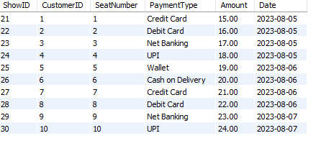

Query -4: Get all notifications for a customer with a given customer ID.  
SELECT NotificationID, Message, Date

FROM Notification

WHERE CustomerID = 1;



Query-5: Get all bookings for a customer with a given customer ID.  
SELECT BookingID, ShowtimeID, TicketID, PaymentID, Date

FROM Booking

WHERE CustomerID = 1;



Query-6: Get all movie titles and their release dates, and all cinema hall names and their locations, in a single table.

SELECT Title, ReleaseDate

FROM Movie

UNION

SELECT Name, Location

FROM CinemaHall;



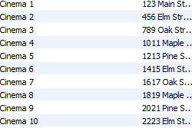

Query -7: Get all ticket details, including the showtime details, customer name, and seat number, for all tickets purchased with a credit card.

SELECT Showtime.MovieID, Showtime.CinemaHallID, Showtime.Date, Showtime.Time, Customer.Name, Ticket.SeatNumber

FROM Ticket

JOIN Showtime ON Ticket.ShowID = Showtime.ShowTimeID

JOIN Customer ON Ticket.CustomerID = Customer.CustomerID

JOIN Payment ON Ticket.TicketID = Payment.TicketID

WHERE Payment.PaymentType = 'Credit Card';

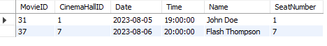

Query-8: Get all customer names and their email addresses.

SELECT Name, Email

FROM Customer;

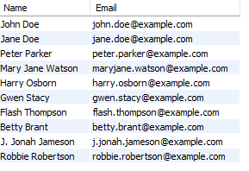

Query-9: Get all cinema hall names and their locations.

SELECT Name, Location

FROM CinemaHall;  
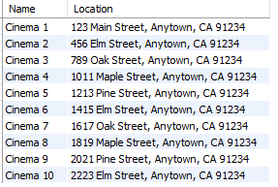

Query-10: Get all showtimes for movies that are having action genre, and are playing on a Friday or Saturday.

SELECT Showtime.MovieID, Showtime.CinemaHallID, Showtime.Date, Showtime.Time

FROM Showtime

JOIN Movie ON Showtime.MovieID = Movie.MovieID

WHERE Movie.Genre = 'action'

AND DAYOFWEEK(Showtime.Date) IN ('Friday', 'Saturday');

